RWE NPOWER FORECASTING CHALLENGE 2015

## TASK

It is important for an energy supplier to be able to forecast its customers' electricity and gas consumption as accurately as possible in order to hedge it accurately and thus avoid exposure to the very volatile prices which are charged on the wholesale markets.

The challenge is to forecast daily gas consumption for three 6 month periods.

Attached and available on the website are .csv files containing the relevant data. There is:

* A training set – data sets on which to train forecast models. This comprises observations of several explanatory (independent) variables with hourly granularity and of one dependent variable, daily consumption.
* A forecasting set – data sets for the forecast period, structured in the same way as the training set, but without the consumption observations.

The chart below shows which periods are covered by the training and forecasting sets in each round of the challenge.

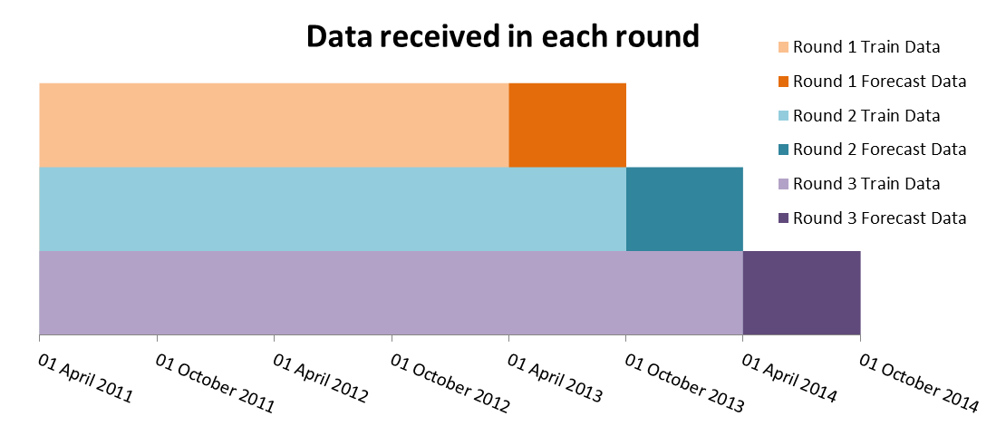

|  |  |
| --- | --- |
| VARIABLE DESCRIPTIONS Date – Date of observation  Temp – Temperature (°C)  Cloud_Cover – Cloud cover (Okta)  Wind_Speed – Wind speed (ms-1)  Humidity – Relative humidity (%)  Precip_Amt – Rainfall equivalent (mm)  Solar_Rad – Solar radiation (kJm-²)  Day_type – Different day types and holidays  School_holiday – 1 if school holiday, 0 otherwise  Winter – 1 if winter, 0 otherwise  Volume – Gas consumption (kWh) | DAY TYPES WE – Weekday  SA – Saturday  SU - Sunday  CD – Christmas Day  BD – Boxing Day  J1 – New Years Day  GF – Good Friday  EM – Easter Monday  M1 – Early May Bank Holiday  M2 – End of May Bank Holiday  A2 – End of August Bank Holiday SD – Special Day |



***Forecasting Challenge 2015***